Fourier Series with Harmonic Analysis

EXPERIMENT - 8

CODE: -

clc

clear all

syms x

p=input('enter the period of the function f:');

l=p/2;

X=input('enter x-vector in radians');

Y=input('enter y-vector in radians'); %Assumed that f(x)=y

K=length(X);

M=input('enter the number of terms required in FS:');

a_0=(2/K)*(sum(Y));

for n=1:M

    a(n)=(2/K)*sum(Y.*cos(n*pi*X/l));

    b(n)=(2/K)*sum(Y.*sin(n*pi*X/l));

end

for n=1:M

    F_S(n)=a(n)*cos(n*pi*x/l)+b(n)*sin(n*pi*x/l);

end

FS=a_0/2+sum(F_S);

disp('Fourier series of the given function is given by')

disp(simplify(FS))

ezplot(FS,[-l,l])

Input 1: -

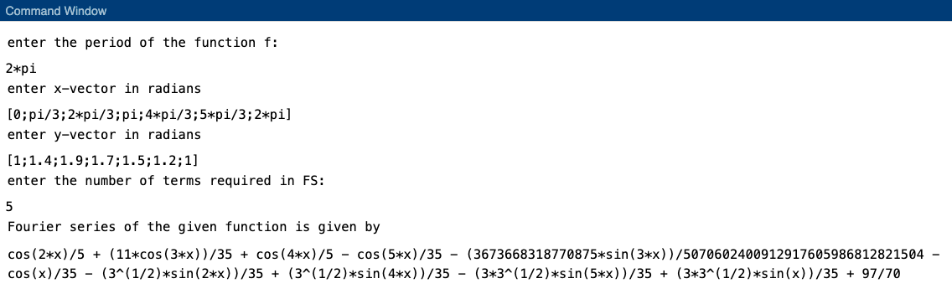

Graph: -

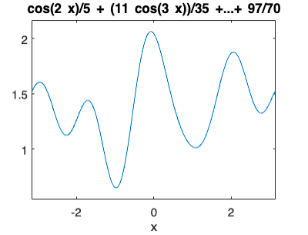

Input 2: -

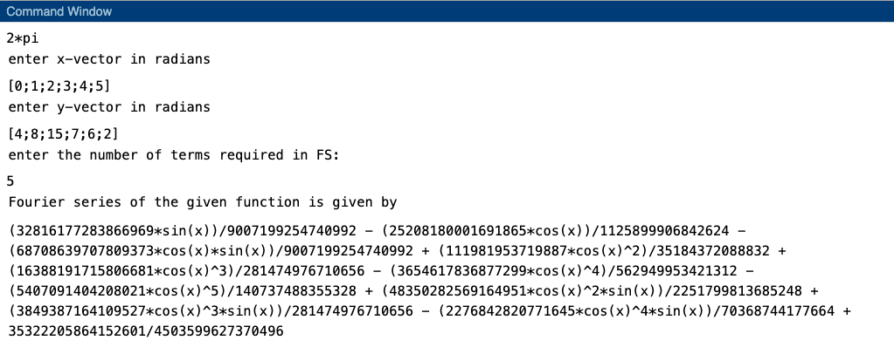

Graph: -

